Bifunctionality in Organometallic Catalysis

Jitendra K. Bera
Department of Chemistry, Indian Institute of Technology Kanpur, Kanpur 208016.
E-mail: jbera@iitk.ac.in
Web: http://home.iitk.ac.in/~jbera/

The ‘synergism’ between different components (metal and ligand) is being increasingly exploited in organometallic catalysis. Bimetallic catalysis is based on the premise that enhanced reaction rate and higher selectivity might emerge from the cooperative participation of two metal ions. Even new catalytic transformations have been contemplated originating from cooperative action between metal ions. Towards this objective, a variety of dinuclear complexes, with or without metal-metal bonds, are synthesized and their catalytic properties are evaluated.¹⁻⁵ In a different approch, bifunctional catalysts are developed to employ water as a reagent.⁶ Hydration of nitriles and olefin-oxidation reactions are carried out in which the metal and the ligand cooperate in a synergistic manner and their interplay facilitates the chemical process. The same principle is used for the synthesis of organic amide from alcohoal and amine. For this purpose, naphthyridine functionalized N-heterocyclic carbene (NHC) ligands are developed and their complexation reactions with a variety of metal ions are studied.⁷⁻¹⁰ This talk would also focus on the bifunctional activation of C-H bond and its relevance in organometallic catalysis.¹¹⁻¹³

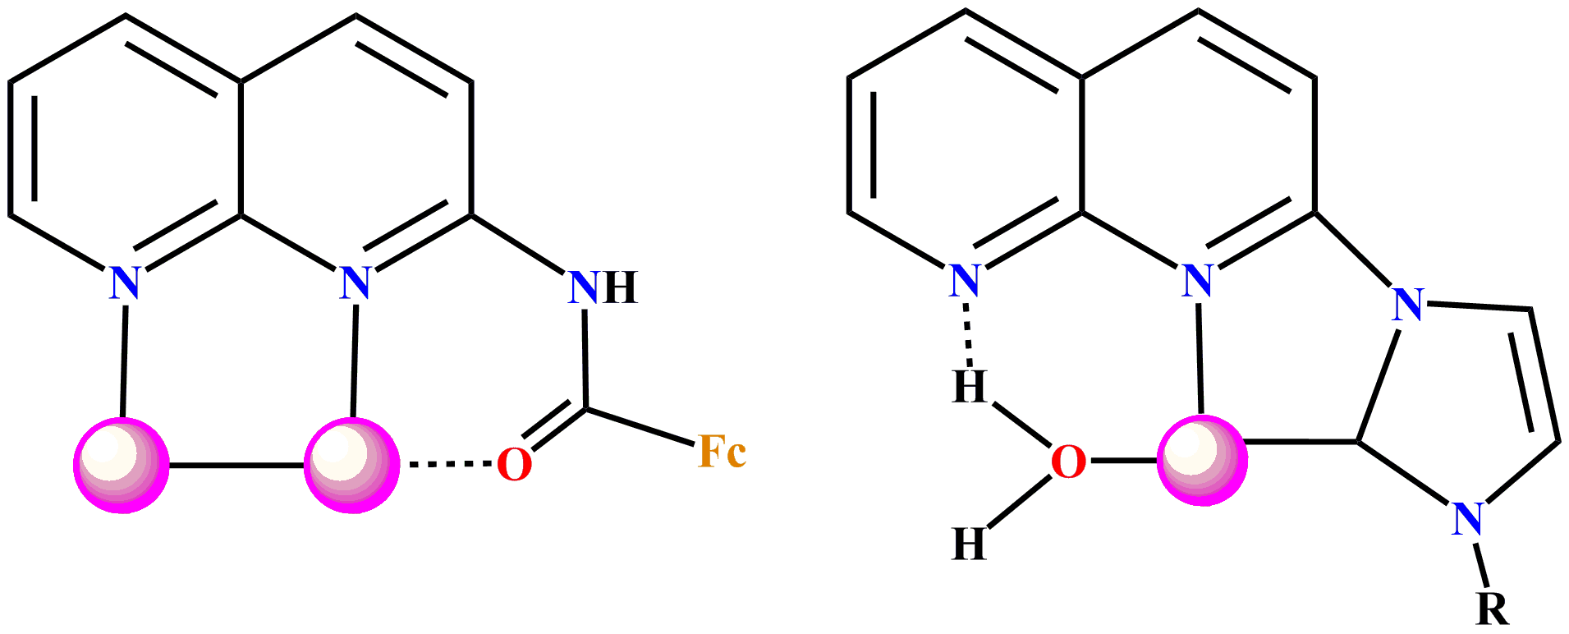

References
(1) Chem. Commun. 2013, 49, 9764. (2) Organometallics 2013, 32, 9764. (3) Eur. J. Inorg. Chem. 2012, 1680. (4) Organometallics 2011, 30, 2051. (5) Chem. –Eur. J. 2010, 16, 2574. (6) Chem. –Eur. J. 2010, 16, 14459. (7) Organometallics 2012, 31, 3790. (8) Organometallics 2012, 31, 5533. (9) J. Organomet. Chem. 2011, 696, 1248. (10) Inorg. Chem. 2009, 48, 11114. (11) Organometallics 2013, 32, 192. (12) Organometallics 2013, 32, 340. (13) Organometallics 2006, 25, 6054.

A short CV of the speaker



Your color photograph here

Jitendra K. Bera

Professor
Department of Chemistry and Center for Environmental Science and Engineering, IIT Kanpur, Kanpur 208016, India.
E-mail: jbera@iitk.ac.in
Webpage: http://home.iitk.ac.in/~jbera/

Bera received his M. Sc. from the University of Kalyani in 1993 and his Ph. D. from the Indian Institute of Science in 1999. After a couple of postdoctoral stints at Purdue University and at Texas A&M University, he joined the faculty at IIT Kanpur in 2003 where he is presently a Professor. He is the recipient of the Ramanna fellowship and the Swarnajayanti fellowship from DST, India, and has received the CRSI bronze medal for the year 2011. Bera's research interests span synthetic, structural and mechanistic organometallic chemistry. Recent efforts are directed toward bifunctional activation of small and abundant molecules and their catalytic transformations to useful chemicals. Bera is recently elected as fellow to Indian academy of science (FASc).

Selected important references:
- Chem. Commun. 2013, 49, 9764.
- Organometallics 2013, 32, 340.
- Inorg. Chem. 2013, 52, 1432.
- Organometallics 2013, 32, 192.
- Organometallics 2013, 32, 4306.
- Organometallics 2012, 31, 5533.
- Organometallics 2012, 31, 3790.
- Inorg. Chem. 2012, 51, 1319.
- Organometallics 2011, 30, 2051.
- Chem. Commun. 2011, 47, 10836.

